 VINOD SIR’S GROUP TUTION

MARKS: 20 MATHS-II TIME: 1 Hr. 30 Mins.

Q. 1: [2]
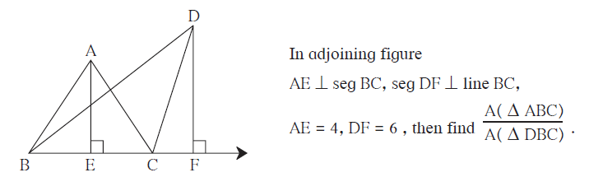
Q. 2:
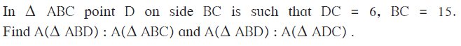[2]
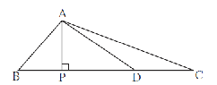

Q. 3: 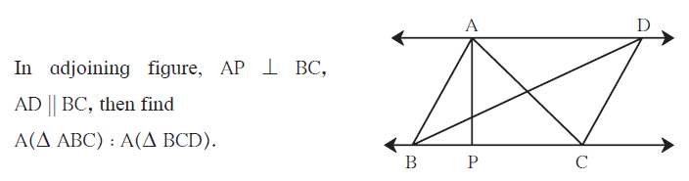[3]

Q. 4: 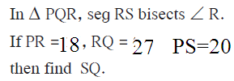 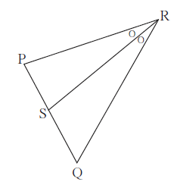 [3]

Q. 5: 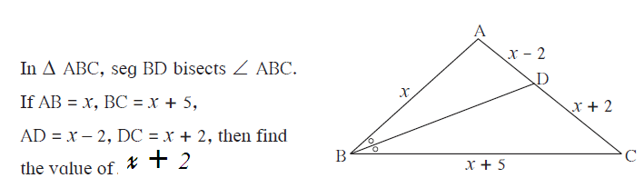 [3]

Q. 6: 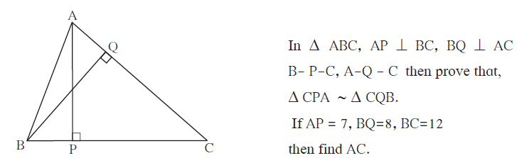 [3]

Q> 7: [4]

